HOME ED EDUCATIONAL PACK

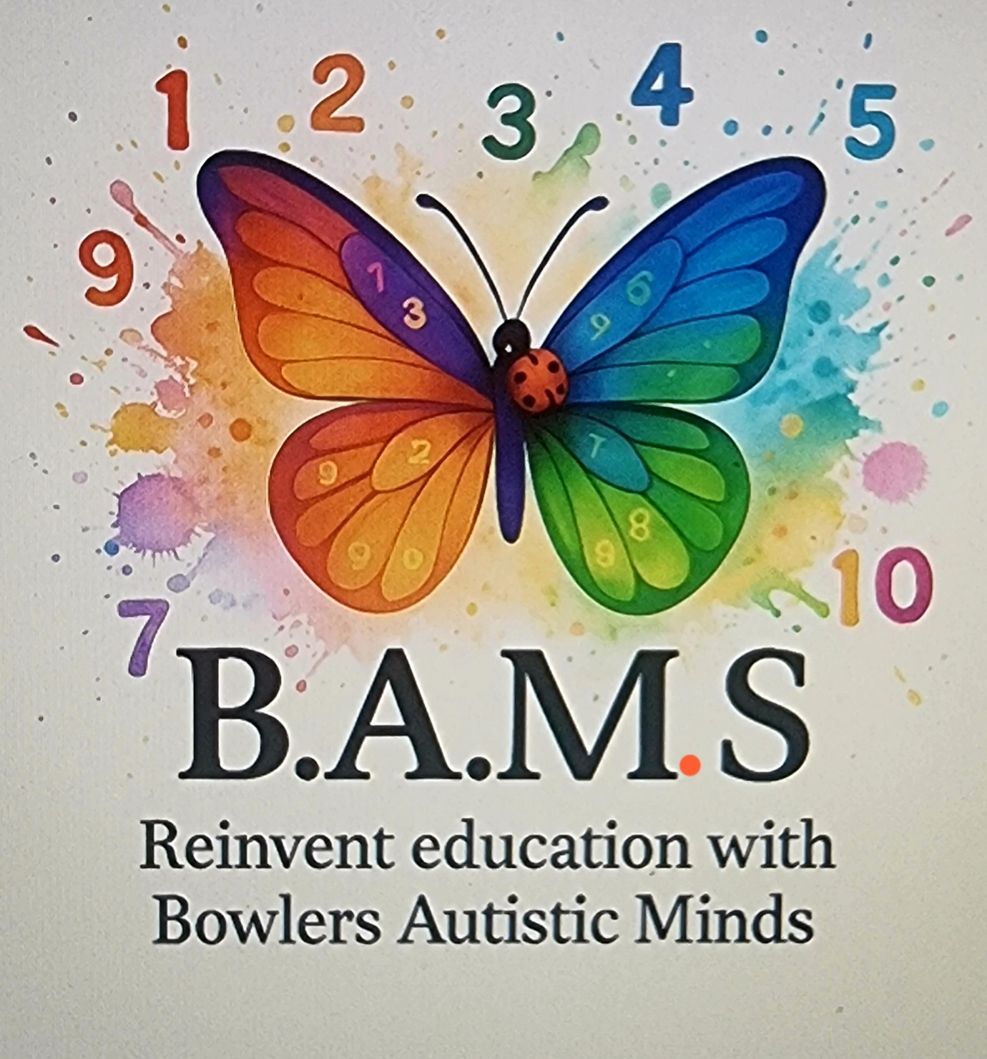
https://www.inclusivemindsco.tech/

Welcome!
Thank you for your interest in B.A.M..S — a part-time, project-based educational setting designed specifically for home educated children aged 5–10. Our sessions are child-led, creative, and flexible — offering the best of learning without the pressure of school.

Our Vision
To create a nurturing and engaging environment where children can explore their interests, develop key life skills, and connect with peers — all through meaningful projects that spark curiosity and joy.

What We Offer
- Child-Led Learning: Children choose what they want to learn and explore within a broad theme. We follow their questions and ideas.
- Project-Based Approach: Learning is hands-on, practical, and connected to real life.
- Small Groups (Max 10 Children): Ensures every child feels seen, heard, and supported.
- No Tests or Homework: Just a focus on joyful, purposeful learning.
- Enrichment, Not Replacement: Complements your home education, rather than replacing it.

How a Session Looks
A typical 2 hour session may include:
- Welcome Circle: Time to check in, share ideas, and plan the day.
- Project Time: Children work in small groups or individually on their chosen topic.
- Exploration Zones: Areas with books, crafts, building materials, natural objects, etc.
- Reflection & Sharing: Time to talk about what they’ve done, learned, or discovered.
Example Projects:
- Build a Bug Hotel
- Design a Fantasy Island
- Create a Mini-Museum
- Investigate Volcanoes
- Invent a New Animal

Educational Benefits
Through these sessions, your child will:
- Grow in confidence and independence
- Develop problem-solving and critical thinking skills
- Improve communication and collaboration
- Make meaningful connections across subjects
- Enjoy learning in a pressure-free environment

Who It’s For
- Home educated children aged 5–10
- Families looking to enrich home education with social, hands-on learning

Practical Information
- Group Size: Max 10 children per session
- Location: Bolsover
- Session Length: 2 hours per week
- Cost: £20
- What to Bring: A named water bottle, snack, suitable clothing (messy play happens!)

Our Approach
We believe children learn best when they are:
- Interested in the topic
- Given time and space
- Respected as individuals
- Supported to make mistakes and try again
Our facilitators are experienced, passionate and trained in child-led and project-based methodologies.

Next Steps
- Meet the team and explore the space
- Ask questions — we’re happy to chat!

Contact Us
Hayley Bowler
bowlerap@outlook.com
https://www.inclusivemindsco.tech/
Let your child lead the way — and love learning again!

AIMS
• Encourage Curiosity and Independent Thinking
To foster a natural love of learning by allowing children to explore topics that interest them, ask questions, and develop their own ideas and projects.
• Promote Child-Led Learning
To empower children to take ownership of their education by choosing projects, setting goals, and reflecting on their own progress.
• Develop Critical Thinking and Problem-Solving Skills
To provide opportunities for children to engage in inquiry-based learning that encourages analysis, experimentation, and creative problem-solving.
• Support Social and Collaborative Skills
To encourage teamwork, communication, and negotiation through group projects and shared learning experiences.
• Provide Opportunities for Real-World Learning
To connect learning to real-life contexts through hands-on, meaningful projects that reflect the children’s interests and everyday lives.
• Respect Individual Learning Styles and Paces
To allow children to work at their own pace and in ways that suit their learning preferences, without pressure or rigid assessment.
• Foster Resilience and Confidence
To support children in managing challenges, making mistakes, and reflecting on outcomes, helping them build self-confidence and emotional resilience.
• Encourage Cross-Curricular Connections
To help children see the links between subjects like science, literacy, art, and maths by exploring them within integrated, project-based learning themes.
• Promote Enjoyment and Wellbeing in Learning
To create a low-pressure, enjoyable environment that supports mental wellbeing and enthusiasm for learning.
• Build Community and a Sense of Belonging
To offer a nurturing space where children form positive relationships with peers and facilitators, feeling part of a supportive learning community.

DELIVERY

🧭 1. Flexible Planning Framework
- Each term we will set a project theme (e.g. “Space”, “Nature & Environment”, “Inventions”, “Community”) that allow individual interests to grow within them.
- We will create open ended learning prompts rather than fixed lessons, e.g., “How do people make electricity?” or “What can we build using recycled materials?”
- We will always allow children to co-construct the learning journey through brainstorming, voting, or proposing their own sub-topics.

🧑‍🏫 2. Role of the Facilitator (Not Traditional Teacher)
- We will always act as a guide and supporter, not a director.
- Observe children’s interests, ask open-ended questions, provide resources, and scaffold when needed.
- Help children reflect on their learning and set personal or group goals.

🪑 3. Group Structure & Management
- On occasions we may divide the group of 10 into smaller working groups (e.g., pairs or trios) for parts of the session to allow for more focused collaboration.
- Use rotating stations or zones: e.g., “research station,” “creative station,” “build/test area,” and “reflection circle.”
- Include whole-group gatherings at the start (for check-in, sharing ideas) and end (for feedback, celebration of learning).

🧰 4. Resource-Rich, Adaptable Environment
- Provide materials such as:
  - Arts and crafts
  - Science and construction kits
  - Books, tablets, reference materials
  - Loose parts and recycled objects
- Ensure the space invites exploration and is flexible for movement and collaboration.

5. Encourage Peer Collaboration
- Encourage peer mentorship: older or more confident children can support others.
- Use group roles like “recorder,” “researcher,” “maker,” and “presenter” to support teamwork and ownership.

📋 6. Keep a Record of Learning
- We will be using learning journals for each child.
- This will include photos, drawings, mind maps, notes, and self-reflections.
- Hold regular mini-presentation sessions where children share what they’ve discovered or made where parents/carers are invited.

Session Diaries and Parent Communication
Each child will receive a personal session diary, which will be completed by educators after each session. This will provide a clear record of the activities, progress, and any notable observations from the day. There will also be space for parents/carers—and children where appropriate—to share feedback, comments, or any important updates from home. We believe that strong, open communication between parents and educators is essential in supporting each child’s development and wellbeing.
At the end of each term, all work completed by the child will be sent home. This allows families to keep a full record of learning and, where applicable, include it in Elective Home Education (EHE) reports.
Please see the sample of a personal session diary:

Session Diary
This diary should be completed by educators after each session. There is space for parent/carer and child comments below. Please use this as a communication tool to support the child's learning journey.

Date:
____________________________________________________________________________________________________
____________________________________________________________________________________________________
____________________________________________________________________________________________________

Session Summary:
____________________________________________________________________________________________________
____________________________________________________________________________________________________
____________________________________________________________________________________________________
____________________________________________________________________________________________________
____________________________________________________________________________________________________
____________________________________________________________________________________________________
____________________________________________________________________________________________________
____________________________________________________________________________________________________

Activities Completed:
____________________________________________________________________________________________________
____________________________________________________________________________________________________
____________________________________________________________________________________________________
____________________________________________________________________________________________________
____________________________________________________________________________________________________
____________________________________________________________________________________________________

Observations (social, emotional, sensory, etc.):
____________________________________________________________________________________________________
____________________________________________________________________________________________________
____________________________________________________________________________________________________
____________________________________________________________________________________________________
____________________________________________________________________________________________________
____________________________________________________________________________________________________

Next Steps / Follow-up Ideas:
____________________________________________________________________________________________________
____________________________________________________________________________________________________
____________________________________________________________________________________________________
____________________________________________________________________________________________________

Educator Signature:
____________________________________________________________________________________________________
____________________________________________________________________________________________________

Parent/Carer Comments:
____________________________________________________________________________________________________
____________________________________________________________________________________________________
____________________________________________________________________________________________________
____________________________________________________________________________________________________

Child's Comments (if applicable):
____________________________________________________________________________________________________
____________________________________________________________________________________________________
____________________________________________________________________________________________________
____________________________________________________________________________________________________

Safeguarding

🛡️ Safeguarding and Safety
Safeguarding is of utmost importance at B.A.M.S.
- All staff and visitors are enhanced DBS checked
- Risk assessments are conducted for all sessions, venues, and activities
- A full copy of our Safeguarding Policy is available on our website

